Q- Introduce yourself.
Ans- Hi, I am Rushikesh Patil. I have overall 5.8 Year of Experience in Automation and Functional Testing. Currently I am in Capgemini as a Senior Automation Tester. My core technical strength in Automation Framework using Java, Selenium WebDriver, Test NG, Cucumber BDD and API Testing.
I am specialized in Banking Domain where working in different streams like Cards, Payment, Loan

Q- Explain your framework.
Ans- FrameWork_With Test Cases.pdf
Step 1: Start with an Introduction
“In my project, we have developed a Hybrid Automation Framework using Selenium with Java, TestNG, Maven, and Page Object Model (POM) design pattern. This framework is a combination of Data-Driven and Keyword-Driven approaches, which helps us achieve high reusability, maintainability, and scalability of our test scripts.”
Step 2: Explain the Framework Architecture / Components
Now explain each layer step by step –
- Base / Utility Layer This layer contains all the reusable functions or helper methods that can be used across multiple test cases

Examples:
• Browser initialization
• Screenshot capturing
• Reading data from Excel / Properties file
• Handling alerts, dropdowns, waits, or frames
• Logging and reporting utilities

- Page Object Model (POM) Layer
In this layer, we create separate classes for each page of the application. Each class contains WebElements and their corresponding methods.
Purpose: To achieve code reusability and readability.

- Test Layer (Test Scripts)
This layer contains the actual test cases written using TestNG annotations (@Test, @BeforeMethod, @AfterMethod, etc.). Here, we call the methods from the Page classes.

- Data Layer
This layer handles all the external data. We use Excel / Properties files / JSON to store input data, credentials, and environment configurations.
Examples:
• config.properties → URL, Browser, Timeout values
• TestData.xlsx → Username, Password, etc.

- TestNG Layer
TestNG helps us with test execution, grouping, prioritization, and generating reports.

- Build Management Tool -Maven
– Maven helps in dependency management and build execution. All required jars are managed via the pom.xml file.

- Reporting Layer
We integrate Extent Reports or Allure Reports to generate detailed HTML reports.
Example:
• Displays test status (Pass/Fail/Skip)
• Captures screenshots for failures
• Shows test execution time and environment info
-----------------------------------------------------------------------------------------------------------------------
Login test take test cases in Hybrid framework:
Project Folder Structure HydrisFramework/
│ ├── src/main/java/
│├── pages/
│ │ └── LoginPage.java
│ ├── utils/
│ │ └── DriverFactory.java
│ └── base/
│ └── BaseTest.java
│ ├── src/test/java/
│ └── tests/
│ └── LoginTest.java
│ ├── pom.xml (Maven dependencies)

File-wise Code
- DriverFactory.java (Utility for WebDriver setup)

package utils;
import org.openqa.selenium.WebDriver;
import org.openqa.selenium.chrome.ChromeDriver;

public class DriverFactory {
private static WebDriver driver;

public static WebDriver getDriver()
{
if (driver == null) {

System.setProperty("webdriver.chrome.driver", "drivers/chromedriver.exe");
driver = new ChromeDriver();
driver.manage().window().maximize();

}
return driver;
}

public static void quitDriver() {
if (driver != null) {
driver.quit();
driver = null;
}
}
}

- BaseTest.java (Common setup/teardown)
package base;
import org.openqa.selenium.WebDriver;
import org.testng.annotations.AfterClass;
import org.testng.annotations.BeforeClass;
import utils.DriverFactory;

public class BaseTest {
protected WebDriver driver;

@BeforeClass
public void setUp() {
driver = DriverFactory.getDriver();
}

@AfterClass
public void tearDown() {
DriverFactory.quitDriver();
}
}

- LoginPage.java (Page Object for login)
package pages;
import org.openqa.selenium.By;
import org.openqa.selenium.WebDriver;

public class LoginPage {
private WebDriver driver;

// Locators
private By usernameField = By.id("username");
private By passwordField = By.id("password");
private By loginButton = By.id("loginBtn");
private By errorMessage = By.id("error");

// Constructor
public LoginPage(WebDriver driver) {
this.driver = driver;
}

// Actions
public void enterUsername(String username) {
driver.findElement(usernameField).sendKeys(username);
}

public void enterPassword(String password) { driver.findElement(passwordField).sendKeys(password);
}

public void clickLogin() {
driver.findElement(loginButton).click();
}

public String getErrorMessage() {
return driver.findElement(errorMessage).getText();
}

}

- LoginTest.java (Test cases)

package tests;
import base.BaseTest;
import org.testng.Assert;
import org.testng.annotations.Test;
import pages.LoginPage;

public class LoginTest extends BaseTest {

@Test
public void testValidLogin() {
driver.get("https://example.com/login");
LoginPage loginPage = new LoginPage(driver);

loginPage.enterUsername("validUser");
loginPage.enterPassword("validPass");
loginPage.clickLogin();

Assert.assertEquals(driver.getTitle(), "Dashboard");

}

@Test
public void testInvalidLogin() {
driver.get("https://example.com/login");
LoginPage loginPage = new LoginPage(driver);

loginPage.enterUsername("wrongUser");
loginPage.enterPassword("wrongPass");
loginPage.clickLogin();

Assert.assertEquals(loginPage.getErrorMessage(), "Invalid credentials");

}

}

Key Notes
• Hydris framework usually follows modular folder separation (pages, tests, utils, base).
• Page Object Model (POM) keeps locators and actions in LoginPage.java.
• TestNG is used for test execution (@Test annotations).
• DriverFactory ensures singleton WebDriver instance.
• You can extend this with reporting (ExtentReports), data-driven testing (Excel/CSV), or CI/CD integration.

Q- . Which version of Selenium are you using, and which framework are you working with?
Ans- I am working with Selenium 4 . Hybrid BDD framework built on Java, TestNG, and Cucumber.

Q- What’s the difference between final, finally, and finalize?
Ans-

Keyword-
Purpose
Final- Used for constants, prevents method overriding, prevents class inheritance.
Finally- Block used in exception handling, always executes.
finalize()- Method used for garbage collection before object is destroyed.

Example:

final class Test { } // Cannot be inherited

try {
int x = 10 / 0; }
catch (Exception e) {
System.out.println("Exception caught"); }
finally {
System.out.println("Finally block executed"); // Used in Exception Handling. Executes Code
Regardless of Exception Occurrence.
}

Q- How does a final variable differ from a constant variable?

Ans-
- In Java, both constants and final variables are used to define variables that cannot be changed after initialization.
-The main difference between a final variable and a constant (static and final) is that if you create a final variable without the static keyword. Though its value is un-modifiable, a separate copy of the variable is created each time you create a new object.
Where a constant is un-modifiable and has only one copy throughout the program.

Ex-
final int num = 200;
num = 2544; //error cannot assign a value to a final variable num

Q- Define an abstract class.
Ans - Abstraction-(Hiding): Abstraction is a process of hiding the implementation details and showing only functionality to the user --------------------(Day16)
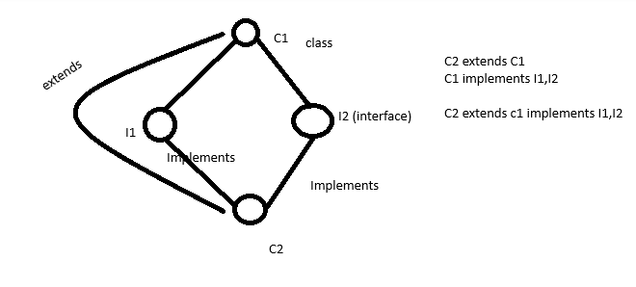
Abstract Class | Interface
Abstract Keyword | interface Keyword
SubClass extends abstract class | Subclasses implements interface
Abstract class can have implemented methods and zero or more abstarct methods | java 8 onwords, interface can have default and static methods
we can extend only one abstarct class | we can implemets multiple interface

Q- Write a program to find triplets in an array. Sum target
For example:
Given a[] = {2, 3, 5, 6, 7, 9}, find combinations where the sum of any two elements equals a target value.

import java.util.ArrayList;
import java.util.Arrays;
import java.util.List;

public class TargetSumPairs {

public static List<int[]> findPairsWithSum(int[] arr, int target) {
List<int[]> result = new ArrayList<>();

// Sort the array first to use the two-pointer approach
Arrays.sort(arr);

int left = 0;
int right = arr.length - 1;

while (left < right) {
int currentSum = arr[left] + arr[right];

if (currentSum == target) {
result.add(new int[]{arr[left], arr[right]});

// Move pointers and avoid duplicates if any
while (left < right && arr[left] == arr[left + 1]) left++;
while (left < right && arr[right] == arr[right - 1]) right--;

left++;
right--;
} else if (currentSum < target) {
left++; // Increase sum by moving left pointer right
} else {
right--; // Decrease sum by moving right pointer left
}
}

return result;
}

public static void main(String[] args) {
int[] a = {2, 3, 5, 6, 7, 9};
int target = 8; // Example target

List<int[]> pairs = findPairsWithSum(a, target);

System.out.println("Pairs that sum to " + target + ":");
for (int[] pair : pairs) {
System.out.println(pair[0] + " + " + pair[1] + " = " + target);
}
}
}

Q- What is the difference between implicit and explicit wait?

Wait Type Definition Behavior

Implicit Wait Global wait that applies to all elements. --> Throws
NoSuchElementException if the
element is not found within the
time.

Explicit Wait Waits for a specific condition before proceeding. Used for specific elements using ExpectedConditions.
Implicit wait
driver.manage().timeouts().implicitlyWait(10,TimeUnit.SECONDS);

Explicit wait / dynamic wait
WebDriverWait wait = new WebDriverWait(driver, Duration.ofSeconds(10)); WebElement element = wait.until(ExpectedConditions.presenceOfElementLocated(By.id("someID")));

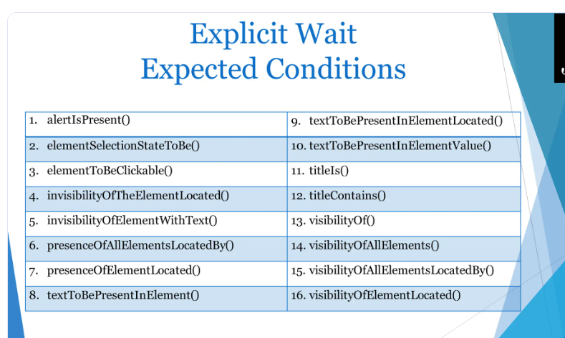

Q- Explain your current/previous project?

Ans-
Project Overview: Global Card Payment Gateway & Authentication Platform
- Domain: Banking & Financial Services (Cards, Payments, and Authorization)

- Project Objective: A high-throughput, secure payment gateway application that processes multi-channel transactions (Web, Mobile, POS) for credit, debit, and prepaid cards. It integrates strict compliance protocols like PCI-DSS and PSD2 (Strong Customer Authentication - SCA).

- Core Modules: Card Authentication (3-D Secure), One-Time Payments (OTP), Recurring Subscriptions/Mandates, and Scheduled Future Payments.

- Tech Stack: Java, Selenium WebDriver, Cucumber (BDD), TestNG, RestAssured (API Testing), Jenkins, Git, Maven, and Oracle SQL.

Key Payment Flows Tested & Validated
1. Card Authentication & 3-D Secure (3DS) Flow
- Functionality: Ensured secure transaction authorization by validating cardholder identity via 2-factor authentication (OTP, biometric prompts, or bank app push notifications).

- Automation Approach: Handled complex UI synchronization issues, dynamic iframes, and popup windows redirected from card issuers (Visa Secure / Mastercard Identity Check) during checkout. Used explicit waits and frame-switching utilities in Selenium.

2. One-Time Payment (OTP) Flow
- Functionality: Validated end-to-end standard checkout transactions where users enter card details (PAN, CVV, Expiry), trigger an OTP, and complete instant settlement.

- Automation Approach: Automated positive and negative scenarios—such as invalid card numbers, expired cards, insufficient funds, and correct OTP validation—combining UI assertions with backend database validation to verify transaction status codes (SUCCESS, DECLINED, PENDING).

3. Recurring Payment & Mandate Flow
- Functionality: Tested automated subscription billing where users authorize a recurring charge (e.g., monthly billing) via e-mandates or tokenized cards.

- Automation Approach: Automated the tokenization process (replacing sensitive PAN with secure tokens) and validated scheduler jobs that trigger automatic payment debits on designated billing dates without requiring re-entry of card credentials.

4. Scheduled Payment Flow
- Functionality: Verified user capabilities to schedule future payments (e.g., bill pay, loan installment transfers) for specific future dates or event-driven triggers.

- Automation Approach: Validated the creation, modification, and cancellation of scheduled instructions, ensuring database timestamps and batch-processing jobs executed transactions accurately at the scheduled time.

Automation Framework & Technical Contributions
- Framework Architecture: Designed and maintained a Behavior-Driven Development (BDD) framework using Cucumber and Java, allowing business-readable .feature files to map directly to step definitions for payment workflows.

- Hybrid Testing Strategy: Combined Selenium WebDriver for UI-based checkout journey validation with RestAssured for backend API testing, verifying payment gateway request/response payloads (JSON/XML) and webhook notifications prior to UI execution to optimize test speed.

- Parallel Execution & Stability: Configured TestNG with ThreadLocal WebDriver instances to run multi-browser cross-platform test suites concurrently, reducing overall test execution time significantly.

- CI/CD Integration: Integrated the test suite into Jenkins pipelines, scheduling automated regression runs for every nightly build and deploying automated test reporting via Extent Reports.

Key Business Impact & Challenges Addressed
- Challenge: Dealing with third-party payment simulator redirects and dynamic 3DS authentication challenge windows that frequently caused flaky test scripts.

- Solution: Implemented robust dynamic wait conditions and mocked stub responses for payment gateway error codes, increasing script reliability by over 35%.

- Result: Achieved high regression test coverage across core payment flows, reducing manual testing effort for release cycles and ensuring zero critical defects slipped into production.

Here is a complete BDD framework snippet using Cucumber (Gherkin) and Java with Selenium WebDriver & RestAssured / Assertions to automate the 3-D Secure Card Authentication and One-Time Payment Flow.

1. Feature File (CardPaymentAuthentication.feature)
This feature file uses Gherkin syntax to articulate the complete payment flow, including card detail input, 3DS authentication redirection, OTP verification, and final transaction confirmation.

Gherkin
Feature: Card Payment Authentication and One-Time Payment

@Regression @PaymentGateway
Scenario Outline: Successful One-Time Payment with 3-D Secure Authentication
Given User navigates to the merchant checkout page
When User selects "<CardType>" as payment option
And User enters card details with PAN "<CardNumber>", expiry "<ExpiryDate>", and CVV "<CVV>"
And User clicks on "Proceed to Pay" button
Then User should be redirected to the 3D Secure issuer authentication page
When User enters the authentication OTP "<OTP>" on the issuer page
And User submits the 3DS authentication
Then Payment processing should be successful
And Transaction status in the system should be "SUCCESS"
And User should see the order confirmation with a valid Transaction ID

Examples:
| CardType | CardNumber | ExpiryDate | CVV | OTP |
| Visa | 4532XXXXXXXX1234 | 12/28 | 888 | 123456 |
| Mastercard | 5200XXXXXXXX5678 | 08/29 | 456 | 654321 |

@Negative @PaymentGateway
Scenario: Failed One-Time Payment due to Invalid OTP in 3DS Challenge
Given User navigates to the merchant checkout page
When User selects "Visa" as payment option
And User enters card details with PAN "4532XXXXXXXX1234", expiry "12/28", and CVV "888"
And User clicks on "Proceed to Pay" button
Then User should be redirected to the 3D Secure issuer authentication page
When User enters the authentication OTP "000000" on the issuer page
And User submits the 3DS authentication
Then Payment should be declined with error message "Authentication Failed: Incorrect OTP"
And Transaction status in the system should be "FAILED"

2. Step Definitions (CardPaymentStepDefs.java)
This Java class implements the step definitions mapping directly to the feature file steps, using dynamic Selenium waits for frame switching (handling 3DS popups/iframes) and assertions.
Java
package com.banking.payment.stepdefs;

import io.cucumber.java.en.Given;
import io.cucumber.java.en.When;
import io.cucumber.java.en.Then;
import org.openqa.selenium.By;
import org.openqa.selenium.WebDriver;
import org.openqa.selenium.WebElement;
import org.openqa.selenium.support.ui.ExpectedConditions;
import org.openqa.selenium.support.ui.WebDriverWait;
import org.testng.Assert;

import java.time.Duration;

public class CardPaymentStepDefs {

private WebDriver driver = Hooks.getDriver(); // Managed via Driver Factory / ThreadLocal
private WebDriverWait wait = new WebDriverWait(driver, Duration.ofSeconds(15));

// Page Locators
private final By visaOption = By.id("card-type-visa");
private final By mastercardOption = By.id("card-type-mastercard");
private final By cardNumberInput = By.id("card_number");
private final By expiryInput = By.id("card_expiry");
private final By cvvInput = By.id("card_cvv");
private final By payButton = By.id("btn-proceed-pay");

// 3DS Issuer Frame & Elements
private final By issuerFrame = By.id("3ds-issuer-iframe");
private final By otpInput = By.id("otp_challenge_input");
private final By submitOtpBtn = By.id("btn-submit-otp");

// Order Confirmation Elements
private final By paymentStatusMessage = By.id("payment-status");
private final By transactionIdText = By.id("txn-id-value");
private final By errorMessageText = By.id("error-alert");

@Given("User navigates to the merchant checkout page")
public void userNavigatesToCheckoutPage() {
driver.get("https://checkout.bankinggateway.com/pay");
}

@When("User selects {string} as payment option")
public void userSelectsCardType(String cardType) {
if (cardType.equalsIgnoreCase("Visa")) {
driver.findElement(visaOption).click();
} else {
driver.findElement(mastercardOption).click();
}
}

@When("User enters card details with PAN {string}, expiry {string}, and CVV {string}")
public void userEntersCardDetails(String pan, String expiry, String cvv) {
driver.findElement(cardNumberInput).sendKeys(pan);
driver.findElement(expiryInput).sendKeys(expiry);
driver.findElement(cvvInput).sendKeys(cvv);
}

@When("User clicks on \"Proceed to Pay\" button")
public void userClicksProceedToPay() {
driver.findElement(payButton).click();
}

@Then("User should be redirected to the 3D Secure issuer authentication page")
public void userRedirectedTo3DSPage() {
// Switch to 3DS authentication iframe embedded from the card issuing bank
wait.until(ExpectedConditions.frameToBeAvailableAndSwitchToIt(issuerFrame));
wait.until(ExpectedConditions.visibilityOfElementLocated(otpInput));
Assert.assertTrue(driver.findElement(otpInput).isDisplayed(), "3DS OTP challenge window was not displayed.");
}

@When("User enters the authentication OTP {string} on the issuer page")
public void userEntersAuthenticationOTP(String otp) {
driver.findElement(otpInput).sendKeys(otp);
}

@When("User submits the 3DS authentication")
public void userSubmits3DSAuthentication() {
driver.findElement(submitOtpBtn).click();
// Switch back to parent merchant window after completing 3DS challenge
driver.switchTo().defaultContent();
}

@Then("Payment processing should be successful")
public void paymentProcessingShouldBeSuccessful() {
wait.until(ExpectedConditions.visibilityOfElementLocated(paymentStatusMessage));
String actualStatus = driver.findElement(paymentStatusMessage).getText();
Assert.assertEquals(actualStatus, "Payment Successful", "Payment execution failed!");
}

@Then("Transaction status in the system should be {string}")
public void verifyTransactionStatusInSystem(String expectedStatus) {
// Can be combined with backend API validation / DB check
String txnId = driver.findElement(transactionIdText).getText();
Assert.assertNotNull(txnId, "Transaction ID should not be null.");
System.out.println("Verified Transaction ID: " + txnId + " with status: " + expectedStatus);
}

@Then("User should see the order confirmation with a valid Transaction ID")
public void userShouldSeeOrderConfirmation() {
WebElement txnElement = wait.until(ExpectedConditions.visibilityOfElementLocated(transactionIdText));
Assert.assertTrue(txnElement.getText().startsWith("TXN-"), "Transaction ID format is invalid.");
}

@Then("Payment should be declined with error message {string}")
public void paymentShouldBeDeclinedWithErrorMessage(String expectedError) {
driver.switchTo().defaultContent();
WebElement errorElement = wait.until(ExpectedConditions.visibilityOfElementLocated(errorMessageText));
Assert.assertEquals(errorElement.getText(), expectedError, "Error message mismatch on failed transaction!");
}
}

Q- What are your Roles & Responsibilities as an Automation Engineer?

Ans-
Key Roles & Responsibilities as an Automation Engineer in Banking

1. Test Automation Framework Development & Enhancement
- Framework Maintenance: Designed, enhanced, and maintained hybrid automation frameworks built with Java, Selenium WebDriver, TestNG, and Cucumber (BDD).

- Reusable Components: Developed reusable component libraries, utility classes, and Page Object Model (POM) design patterns to improve script readability and reduce maintenance overhead across core banking modules (cards, payments, loans).

- Parallel Execution: Configured TestNG suite XML files and ThreadLocal WebDriver instances to support parallel cross-browser execution, cutting down overall regression suite execution time.

2. Test Script Creation & Advanced Synchronization
- Core Flows Automation: Automated critical banking workflows including One-Time Payments (OTP), recurring subscriptions/e-mandates, and scheduled payment processing.

- Complex UI Handling: Handled complex web elements specific to financial portals, such as third-party 3-D Secure (3DS) issuer authentication windows, secure iframes, dynamic dropdowns, and multi-factor authentication (MFA) popups using robust explicit waits.

3. API Testing & Database Validation
- Backend Integration: Utilized RestAssured and Java to automate API endpoints and webhook validations for payment gateways prior to UI execution, ensuring faster feedback loops.

- Data Integrity Checks: Performed database validations (using SQL/Oracle) to verify transaction statuses (SUCCESS, DECLINED, PENDING), account ledger updates, and tokenization records post-checkout.

4. CI/CD Pipeline Integration & Execution
- Continuous Testing: Integrated automated regression test suites into Jenkins CI/CD pipelines to trigger automated builds and test runs on every nightly release or code deployment.

- Reporting & Triage: Configured detailed HTML reporting tools (Extent Reports / Allure) and analyzed test failure logs to differentiate between genuine application bugs and test script flakiness.

5. Agile Collaboration & Quality Governance
- Sprint Participation: Collaborated closely with Product Owners, Business Analysts, and Manual QA teams during sprint planning and backlog refinement to understand user stories and acceptance criteria.

- Defect Life Cycle: Logged, tracked, and managed defects using Jira, ensuring strict adherence to compliance standards (such as PCI-DSS guidelines for secure test data handling).

Q- Why do we use Cucumber in automation frameworks? What are its advantages?
Ans-
- Cucumber is an open-source testing framework that supports Behavior-Driven Development (BDD). It enables software teams to define application behavior in plain, human-readable language (Gherkin syntax) using standard keywords such as Given, When, Then, And
- Non-technical stakeholders—such as Business Analysts (BAs), Product Owners (POs), and Client Executives—cannot read or validate code. Cucumber acts as a bridge between technical and business teams.

Key Advantages of Cucumber in Automation
1. Bridges the Gap Between Technical and Non-Technical Teams
2. High Reusability of Step Definitions
- Once a step definition is written (e.g., Given User navigates to the login page), it can be reused across hundreds of scenarios across different feature files without writing duplicate Java code.
3. Data-Driven Testing made Simple (Scenario Outline)
- Passing multiple sets of test data in traditional frameworks requires complex data provider arrays or Excel sheets. Cucumber uses simple, clean Examples: tables directly inside feature files.
4. Seamless CI/CD & Reporting Integration
- Cucumber generates structured outputs (JSON, XML, HTML) natively, making it easy to plug into reporting tools like ExtentReports or Cucumber Jenkins Plugin.
5. Tagging & Selective Execution
- Scenarios can be tagged with annotations like @Smoke, @Regression . You can pass tag expressions in Maven/Jenkins to run only targeted test suites.

Q- Write an XPath to click on the “Orders” button on Amazon.
Ans-
//a[@id='nav-orders'] -- xpath
//span[normalize-space()='Returns'] -- Text-Based XPath
//span[contains (@class, "nav-line-1")] --- XPath Using Attributes and Contains

Q- Difference between Actions class and Action interface in Selenium.
Ans-
In Selenium WebDriver, Actions (plural, class) and Action (singular, interface). While they both belong to the org.openqa.selenium.interactions package and are used for handling complex user gestures (like mouse hovering, drag-and-drop, and keyboard events), they serve entirely different purposes in execution.

Feature | Actions (Class) | Action (Interface)
Type | It is a concrete Java class. | It is a Java interface.
Purpose | Used to build a composite sequence of user actions (design pattern). | Used to store and represent a single built action or complete action sequence.
Method | Contains methods like .moveToElement(), .click(), .dragAndDrop(), and .build(). | Contains a single abstract method: .perform().
Execution | Actions are queued up and executed when .perform() or .build().perform() is called. | Once built into an Action object, execution can be triggered later using .perform().

1. The Actions Class
- What it is: A user-facing helper class in Selenium that implements the Builder Design Pattern.
- How it works: You instantiate the Actions class by passing your WebDriver instance. You then chain multiple user interaction commands together.
- Example:
Actions actions = new Actions(driver);
actions.moveToElement(element).click().build(); // Builds the action queue

2. The Action Interface
- What it is: An interface representing a single ready-to-be-executed user interaction.
- How it works: When you call .build() on the Actions class, it compiles all your queued commands and returns an object of type Action.
- Why use it? If you want to build a complex sequence of keyboard or mouse actions and execute them later—or execute them multiple times—you store them in an Action variable.
- Example:

Actions actions = new Actions(driver);
// Chain multiple events and store as an Action interface
Action seriesOfActions = actions
.moveToElement(usernameField)
.click()
.sendKeys("secure_user")
.keyDown(Keys.CONTROL)
.sendKeys("a")
.keyUp(Keys.CONTROL)
.build();

// Execute the stored action later
seriesOfActions.perform();

Q- Write a Java program to count the frequency of words in:
"java is best java is powerful"
Ans- O/P- Word Frequencies: java : 2 is : 2 best : 1 powerful : 1

import java.util.HashMap;
import java.util.Map;

public class WordFrequencyCounter {
public static void main(String[] args) {
String input = "java is best java is powerful";

// Step 1: Normalize and split the string into words using spaces
String[] words = input.toLowerCase().split("\\s+");

// Step 2: Store word frequencies in a HashMap
Map<String, Integer> wordFrequencyMap = new HashMap<>();

for (String word : words) {
// getOrDefault returns the current count or 0 if the word is not yet in the map
wordFrequencyMap.put(word, wordFrequencyMap.getOrDefault(word, 0) + 1);
}

// Step 3: Print the results
System.out.println("Word Frequencies:");
for (Map.Entry<String, Integer> entry : wordFrequencyMap.entrySet()) {
System.out.println(entry.getKey() + " : " + entry.getValue());
}
}
}

Q- What are Groups in TestNG? Why and how do we use them?
Ans-
In TestNG, Groups allow you to categorize your test methods logically so that you can execute specific subsets of tests—such as smoke tests, regression tests, sanity tests, or payment gateway tests—without needing to run the entire test suite.

We Use
- Selective Test Execution: In large banking automation frameworks with thousands of test cases, running every test for every minor code check takes hours. Groups let you run only relevant tests (e.g., executing just @Test(groups = "smoke") post-deployment).

- Modular Test Suites: You can bundle independent test methods across different classes into named categories (e.g., sanity, regression, apis, ui).

- CI/CD Pipeline Optimization: Jenkins jobs can be configured to trigger specific group suites (like nightly regression vs. fast smoke builds) by referencing group names in the testng.xml file.

How Do We Use Groups? (Step-by-Step Implementation)
1. Assigning Groups in Test Methods
You specify groups inside the @Test annotation using the groups attribute. A single method can belong to one or multiple groups.

import org.testng.annotations.Test;
public class PaymentGatewayTests {

@Test(groups = {"smoke", "regression", "payments"})
public void testOneTimePayment() {
System.out.println("Executing One-Time Payment Test...");
}

@Test(groups = {"regression", "payments", "cards"})
public void testCardAuthentication3DS() {
System.out.println("Executing 3-D Secure Card Authentication Test...");
}

@Test(groups = {"smoke"})
public void testLoginButtonVisibility() {
System.out.println("Executing Smoke Login Test...");
} }
2. Configuring Groups in testng.xml
To execute specific groups, you define them inside your testng.xml file using <run>, <include>, and <exclude> tags.

XML
<?xml version="1.0" encoding="UTF-8"?>
<!DOCTYPE suite SYSTEM "https://testng.org/testng-1.0.dtd">
<suite name="Banking Payment Suite">
<test name="Smoke and Payment Tests">
<groups>
<run>
<!-- Include specific groups to run -->
<include name="smoke"/>
<include name="payments"/>
<!-- Exclude unstable or experimental tests if needed -->
<exclude name="beta"/>
</run>
</groups>
<classes>
<class name="com.banking.payment.PaymentGatewayTests"/>
</classes>
</test>
</suite>

Q- How have you used testng.xml in your framework?
1. Defining Test Suites and Execution Scope
Instead of running tests individually via IDE classes, I used testng.xml to bundle multiple test classes into cohesive suites (e.g., PaymentGatewaySuite.xml, CardAuthenticationSuite.xml). This allows me to define the exact execution sequence of classes and packages.

2. Cross-Browser & Parallel Execution
In banking applications, verifying compatibility across multiple browsers (Chrome, Edge, Firefox) is critical. I utilized testng.xml to configure parallel execution at the test or class level using thread-count and passed browser parameters to WebDriver factories:

XML
<suite name="Banking Regression Suite" parallel="tests" thread-count="3">
<test name="Chrome Payment Tests">
<parameter name="browser" value="chrome"/>
<classes>
<class name="com.banking.payment.tests.OneTimePaymentTest"/>
</classes>
</test>
<test name="Edge Payment Tests">
<parameter name="browser" value="edge"/>
<classes>
<class name="com.banking.payment.tests.CardAuth3DSTest"/>
</classes>
</test>
</suite>

3. Parameterization (<parameter>)
I used <parameter> tags in testng.xml to pass environment-specific configurations (like base URLs, database connection strings, test user credentials, or API endpoints) directly into test methods using the @Parameters annotation, avoiding hardcoded values in code.

4. Group-Based Test Filtering
To manage nightly smoke runs vs. full regression builds, I configured <groups> inside testng.xml to include specific tags (smoke, regression, payments) and exclude unstable or work-in-progress test scripts:

XML
<groups>
<run>
<include name="regression"/>
<exclude name="experimental"/>
</run>
</groups>
5. CI/CD Pipeline Integration (Jenkins)
The testng.xml file is the primary entry point referenced by build tools (Maven pom.xml / Surefire plugin). In Jenkins pipelines, the build job triggers specific XML files depending on the test cycle (e.g., triggering smoke-suite.xml on every pull request and regression-suite.xml on nightly builds).

Q- What is invocationCount in TestNG?
- invocationCount is an attribute of the @Test annotation in TestNG that specifies how many times a particular test method should be executed.
how you use invocationCount in a TestNG test:
import org.testng.annotations.Test;
public class PaymentLoadTest {
// This test method will execute 5 times consecutively
@Test(invocationCount = 5)
public void testConcurrentPaymentSubmission() {
System.out.println("Executing payment transaction attempt on thread: "
+ Thread.currentThread().getId());
}
}

Q- What is a DataProvider in TestNG?
In TestNG, @DataProvider is a annotation used for Data-Driven Testing. It allows you to pass multiple sets of test data directly into a single test method, running that test iteratively for every data row provided.

import org.testng.annotations.DataProvider;
import org.testng.annotations.Test;

public class PaymentDataDrivenTest {

// 1. Define the DataProvider with a unique name
irth public Object[][] paymentTestData() {
return new Object[][] {
{ "Visa", "4532XXXXXXXX1234", 1500.00, "SUCCESS" },
{ "Mastercard", "5200XXXXXXXX5678", 2500.50, "SUCCESS" },
{ "RuPay", "6070XXXXXXXX9999", 500.00, "FAILED" }
};
}
// 2. Connect the test method to the DataProvider using its name
@Test(dataProvider = "paymentTestData")
public void testPaymentGatewayFlow(String cardType, String cardNumber, double amount, String
expectedStatus) {
System.out.println("Testing Payment for Card Type: " + cardType
+ " | Number: " + cardNumber
+ " | Amount: " + amount
+ " | Expected: " + expectedStatus);
}
}
Q- Difference between Scenario vs Scenario Outline in Cucumber.
Feature | Scenario | Scenario Outline
Purpose | Defines a single test case | Runs the same test multiple times with different inputs
Data Handling | Hardcoded values | Uses with Examples
Example | Scenario: Login with valid credentials | Scenario Outline: Login with multiple credentials

Example of Scenario Outline (Data-Driven Test):
Scenario Outline: Login with multiple credentials
Given User is on Login Page
When User enters "username" and "PWD"
Then User is logged in successfully
Examples:
| username | password |
| user123 | pass123 |
| user456 | pass456 |
� � Use Scenario Outline when testing multiple data sets!
Q- How do you pass test data in your automation framework?
"In our automation framework, test data management is categorized based on the nature and scope of the test:
- Environment & Configuration Data: We store static configurations like base URLs, browser types, and database connection strings in .properties files, which are loaded into Java utility classes at runtime.
- BDD & Business Scenarios: For our Cucumber feature files, we use Scenario Outline with Examples: tables or Cucumber Data Tables to pass user credentials, card types, and transaction amounts in a business-readable format.
- Data-Driven & High-Volume Testing: For extensive data variations (like testing multiple payment amounts, currency types, or card issuers), we read test data from external .xlsx files using Apache POI and supply it dynamically to test scripts via TestNG @DataProvider.
- Dynamic Runtime Data: For data generated during execution—such as dynamic Transaction IDs or session tokens that need to pass from API responses to UI validations—we use ThreadLocal context stores to ensure thread safety during parallel execution."*

Q- Difference between POM and Page Factory.
Page Object Model (POM): Separates UI elements from test scripts.
Page Factory: Uses @FindBy annotations to initialize elements efficiently.
Feature | Page Object Model (POM) | Page Factory
Nature | A Design Pattern (a concept / architectural guideline). | A built-in Selenium Utility Class implementing POM.
Locator Declaration | Uses standard By locators (e.g., By.id("username")). | Uses annotations like @FindBy(id = "username").
Initialization | Elements are typically located using driver.findElement(locator) inside methods or constructors. | Elements are initialized dynamically using PageFactory.initElements().
StaleElementReferenceException | Less prone to stale elements if findElement. | More prone to StaleElementReferenceException because Page Factory
Pure POM Approach
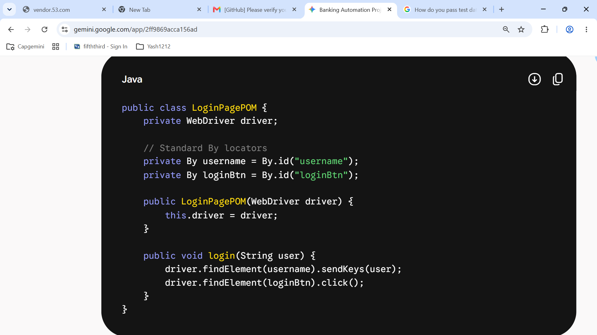
Page Factory Approach
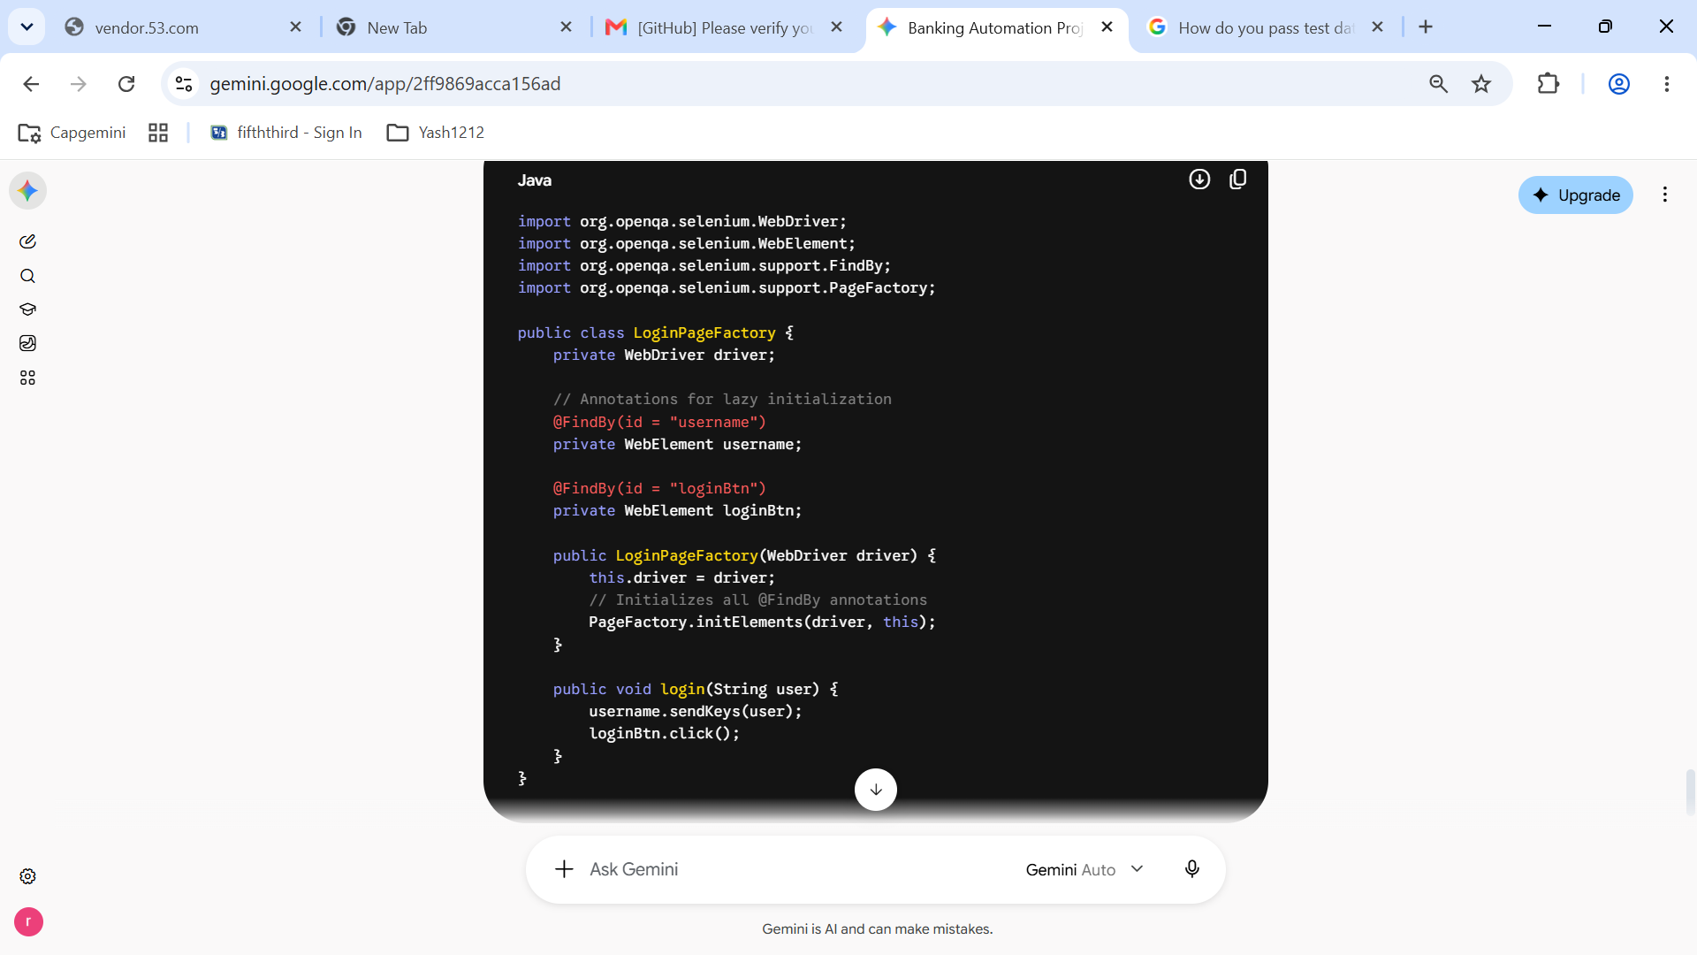

Q- What does getDomProperty() and getDomAttribute() do? What is the difference?
Why is getAttribute() used? used to fetch the runtime value of an HTML element's attribute (such as value, placeholder, src, href, class, or disabled) from the Web Page DOM.

1. What is an HTML Attribute (getDomAttribute)?
- Definition: Attributes are defined in the static HTML markup of the webpage. They represent the initial values written in the source code and do not change when the user interacts with the element.
- Examples: id, class, type, placeholder, or default value attributes written in HTML.
- Method: element.getDomAttribute("value") retrieves the initial value hardcoded in the HTML markup, regardless of user input.
2. What is a DOM Property (getDomProperty)?
- Definition: Properties are part of the DOM tree object maintained in the browser’s memory. They represent the current, live, real-time state of an element, which updates dynamically as the user interacts with the page (via JavaScript or UI actions).
- Examples: Current user-typed text in a text box, the checked/unchecked state of a checkbox or radio button, or disabled states.
- Method: element.getDomProperty("value") retrieves what the user has actively typed into a field right now.

Q- How to fetch all broken links with their name and URL?

import org.openqa.selenium.By;
import org.openqa.selenium.WebDriver;
import org.openqa.selenium.WebElement;
import org.openqa.selenium.chrome.ChromeDriver;
import java.io.IOException;
import java.net.HttpURLConnection;
import java.net.URL;
import java.time.Duration;
import java.util.List;

public class BrokenLinksFinder {
public static void main(String[] args) {
WebDriver driver = new ChromeDriver();
driver.manage().window().maximize();
driver.manage().timeouts().implicitlyWait(Duration.ofSeconds(10));

// Navigate to the target web application
driver.get("https://example.com/banking/dashboard");

// Step 1: Collect all anchor tags with 'href' attribute
List<WebElement> links = driver.findElements(By.tagName("a"));
System.out.println("Total links found on page: " + links.size());

int brokenLinksCount = 0;

// Step 2: Iterate through each link and check HTTP response
for (WebElement link : links) {
String urlString = link.getAttribute("href");
String linkName = link.getText().trim();

// Validate if the URL is null, empty, or points to JavaScript/mail
if (urlString == null || urlString.isEmpty()) {
System.out.println("URL for link '" + linkName + "' is empty or null.");
continue;
}

if (urlString.startsWith("javascript") || urlString.startsWith("mailto:")) {
// Skip non-HTTP links
continue;
}

try {
URL url = new URL(urlString);
HttpURLConnection connection = (HttpURLConnection) url.openConnection();
connection.setConnectTimeout(5000); // 5 seconds timeout
connection.setRequestMethod("GET");
connection.connect();

int responseCode = connection.getResponseCode();

// Step 3: Identify broken links (HTTP status code >= 400)
if (responseCode >= 400) {
brokenLinksCount++;
System.out.println("[BROKEN LINK] Name: \"" + linkName + "\" | URL: " + urlString + " | Status Code: " + responseCode);
} else {
System.out.println("[VALID LINK] Name: \"" + linkName + "\" | URL: " + urlString + " | Status Code: " + responseCode);
}
} catch (IOException e) {
brokenLinksCount++;
System.out.println("[BROKEN/ERROR LINK] Name: \"" + linkName + "\" | URL: " + urlString + " | Exception: " + e.getMessage());
}
}
System.out.println("\nTotal Broken Links Found: " + brokenLinksCount);
// Close the browser
driver.quit();
}
}

Q- How can you bypass “Element Not Found” without using try-catch / throws / custom exceptions?
- Without try/catch block:
WebDriverWait wait = new WebDriverWait(driver, Duration.ofSeconds(10));
WebElement element = wait.until(ExpectedConditions.visibilityOfElementLocated(By.id("elementID") ));

- With try/catch block:
try {
WebElement element = driver.findElement(By.id("elementID"));
}
catch (NoSuchElementException e)
{
System.out.println("Element not found!");
}

Q- What happens when multiple browser windows are open? How do you switch between them? / Handle Multiple Windows

✅ Switch to a New Window
String parentWindow = driver.getWindowHandle();
for (String windowHandle : driver.getWindowHandles()) {
if (!windowHandle.equals(parentWindow))
{
driver.switchTo().window(windowHandle);
}
}

✅ Switch Back to Parent Window
driver.switchTo().window(parentWindow);

Q- When should you use sendKeys() and when sendKeys() from Actions class?
In Selenium WebDriver, sendKeys() can be called in two distinct ways
- WebElement (element.sendKeys())
- Actions class (actions.sendKeys())

-WebElement (element.sendKeys())
when you are filling out standard form fields like text boxes, password fields, or text
areas.
Ex.
WebElement cardNumberField = driver.findElement(By.id("card-number"));
cardNumberField.sendKeys("4532123456789999");

-Action class (actions.sendKeys())-
perform keyboard operations
Ex.
Actions actions = new Actions(driver);
actions.sendKeys(Keys.ENTER).perform();

Q- How does WebDriverWait urlToBe() differ from titleIs()?

// 1. Wait until the browser URL matches the expected payment success endpoint wait.until(ExpectedConditions.urlToBe("https://example.com/banking/payment-success"));
// 2. Wait until the browser tab title matches the confirmation page header wait.until(ExpectedConditions.titleIs("Secure Payment Confirmation"));

Q- How do you handle dynamic dropdowns and select options?

- dropdowns with the <select> tag, we use Selenium’s built-in Select class (selectByVisibleText, selectByValue, etc.).
- However, for modern dynamic dropdowns and auto-suggestions that render custom div or li elements, we use explicit waits to ensure options load, fetch them into a List<WebElement>, iterate through them, and click the matching option

1. Static Dropdowns (<select> tag)
When a dropdown uses the standard HTML <select> tag, Selenium provides a built-in Select class to handle selections easily by index, value, or visible text.

public class StaticDropdownExample {
public static void selectCardType(WebDriver driver) {
WebElement dropdownElement = driver.findElement(By.id("card-type-select"));

// Wrap the element in the Select class
Select select = new Select(dropdownElement);

// Select by Visible Text
select.selectByVisibleText("Mastercard");

// Or select by Value attribute
// select.selectByValue("MC_02");

// Or select by Index
// select.selectByIndex(1);
}
}

2. Dynamic Dropdowns & Auto-Suggestions (Custom UI Dropdowns)
Many modern web applications (like banking portals searching for a bank branch or country code) use custom <div>, <ul>, or <li> tags instead of <select>. These options load dynamically as you type.

public class DynamicDropdownExample {
public static void selectDynamicOption(WebDriver driver, WebDriverWait wait, String targetCountry) {
// 1. Type into the dynamic search box
WebElement searchBox = driver.findElement(By.id("country-search-input"));
searchBox.sendKeys("Ind");

// 2. Wait for the dynamic suggestion list to appear in the DOM
By suggestionsLocator = By.xpath("//ul[@id='suggestions-list']//li");
wait.until(ExpectedConditions.visibilityOfAllElementsLocatedBy(suggestionsLocator));

// 3. Fetch all suggestion items into a List
List<WebElement> options = driver.findElements(suggestionsLocator);

// 4. Iterate and click the matching option
for (WebElement option : options) {
String optionText = option.getText().trim();
if (optionText.equalsIgnoreCase(targetCountry)) {
option.click();
System.out.println("Selected dynamic option: " + optionText);
break;
} } } }

Q- How do you manage AutoFill fields and validate listed options?

- simply sending keys via sendKeys() is often not enough to trigger the dropdown event listeners.
- Use explicit waits to ensure the input field is interactive.
- Handle Synchronization (Explicit Waits), use WebDriverWait with ExpectedConditions.visibilityOfAllElementsLocatedBy:

Ex.
WebDriverWait wait = new WebDriverWait(driver, Duration.ofSeconds(10));
By suggestionListLocator = By.cssSelector(".autocomplete-suggestions li");
// Wait for at least one suggestion to appear
wait.until(ExpectedConditions.visibilityOfElementLocated(suggestionListLocator));

-capture and Extract Listed Options
List<WebElement> suggestions = driver.findElements(suggestionListLocator);

- Select the Target Option

for (WebElement option : suggestions) {
if (option.getText().equals("Visa Debit")) {
option.click();
break;
}
}

Q- When should you validate a URL’s existence on a web page? What are hidden links?
Part 1: When should you validate a URL’s existence on a web page?
- returning 404 Not Found or 500 Internal Server Error responses (returning 404 Not Found or 500 Internal Server Error responses)

Q- How do you switch back from a frame?
- To switch back from an iframe to the main page
driver.switchTo().defaultContent();

Q- What ChromeOptions have you used and why?
- ChromeOptions is essential for stability, CI/CD pipeline compatibility, security compliance, and performance.
- ChromeOptions used in real-world framework setups

addArguments("--headless=new") Runs browser tests in headless mode
addArguments("--start-maximized") Opens the browser maximized
addArguments("--incognito") Ensures an isolated, clean browser session without cached cookies
addArguments("--disable-notifications") Automatically suppresses browser pop-ups (eg - location or push notifications)
Ex.
ChromeOptions options = new ChromeOptions();
options.addArguments("--remote-allow-origins=*");

Q- How do you move from one window to another and create a new blank tab?
- driver.getWindowHandle();
- Create a New Blank Tab
using driver.switchTo().newWindow(WindowType.TAB) creates a new blank tab

Get current window ID :
String handle = driver.getWindowHandle();
Get all open window IDs :
Set<String> handles = driver.getWindowHandles();
Create & switch to new blank tab :
driver.switchTo().newWindow(WindowType.TAB);
Create & switch to new blank window :
driver.switchTo().newWindow(WindowType.WINDOW);

Ex-
// Step 1: Store the Parent Window handle
String parentWindowHandle = driver.getWindowHandle();
System.out.println("Parent Window Handle: " + parentWindowHandle);

// Step 2: Open a new tab and switch automatically
driver.switchTo().newWindow(WindowType.TAB);
driver.get("https://payment-gateway.example.com");
// Step 3: Get all open window handles
Set<String> allWindowHandles = driver.getWindowHandles();
// Step 4: Iterate through handles to switch between tabs
for (String handle : allWindowHandles) {
if (!handle.equals(parentWindowHandle)) {
driver.switchTo().window(handle);
System.out.println("Switched to Child Tab Title: " + driver.getTitle());
break;
}
}
// Step 5: Close the current child tab and switch back to parent
driver.close(); // Closes the current active tab
driver.switchTo().window(parentWindowHandle); // Restores focus to original window

Q- If there are multiple similar elements, how does WebDriver identify them?

